**Show_activity_result**

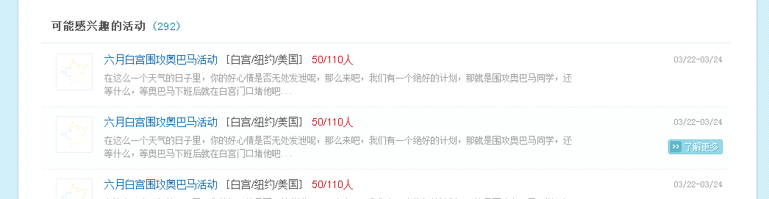

More

Activities may have interests

**Show_group_result**

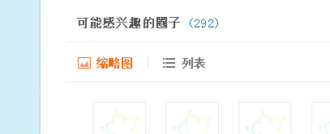

Thumbnail, List

Groups may have interests

**Show_people_result**

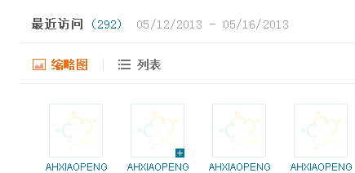

Recent visitors

**Show_people_result_02**

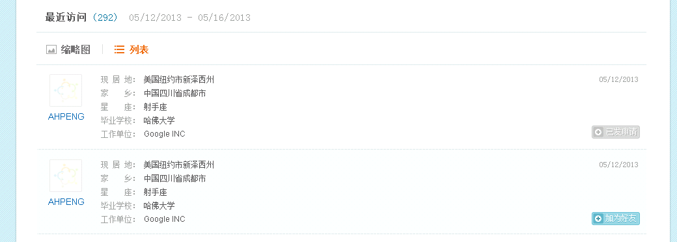

Applied

Make friends

Current place:

Home place:

Constellation:

Graduated from:

Work at:

**Search_result_01**

Search result:

Activity/Friend/Group/Posts

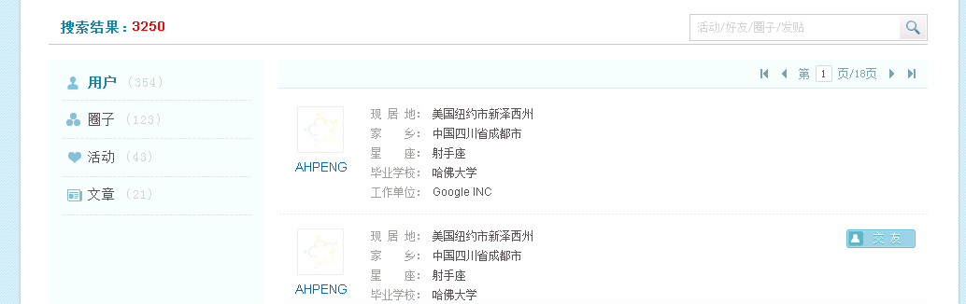

Make friends

User

Group

Activity

Posts

Current place:

Home place:

Constellation:

Graduated from:

Work at:

**Search_result_02**

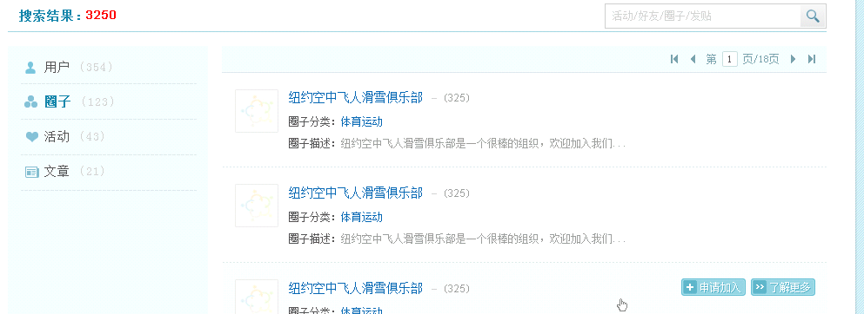

Category:

Description:

Apply, More

**Search_result_03**

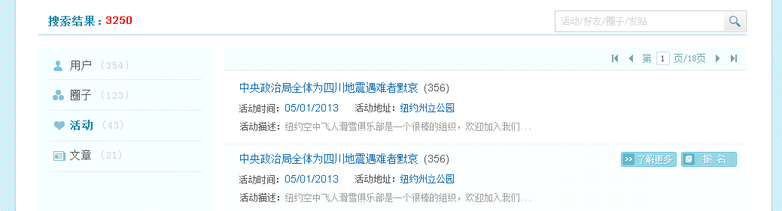

Address:

Date:

Description:

Signup, More

**Search_result_04**

Published:

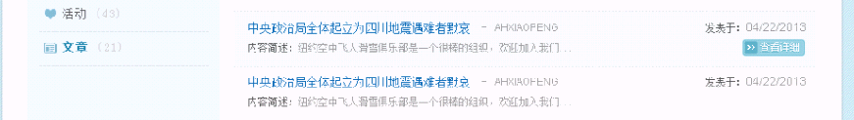

More

Summary: